**Cognizant Week6_HandsOn**

1. **Create a new React Application**

**Code:**

**App.js**

import React from 'react';

function App() {

  return (

    <div>

      <center><h1>Welcome to the first session of React</h1></center>

      <hr></hr>

    </div>

  );

}

export default App;

**Output:**

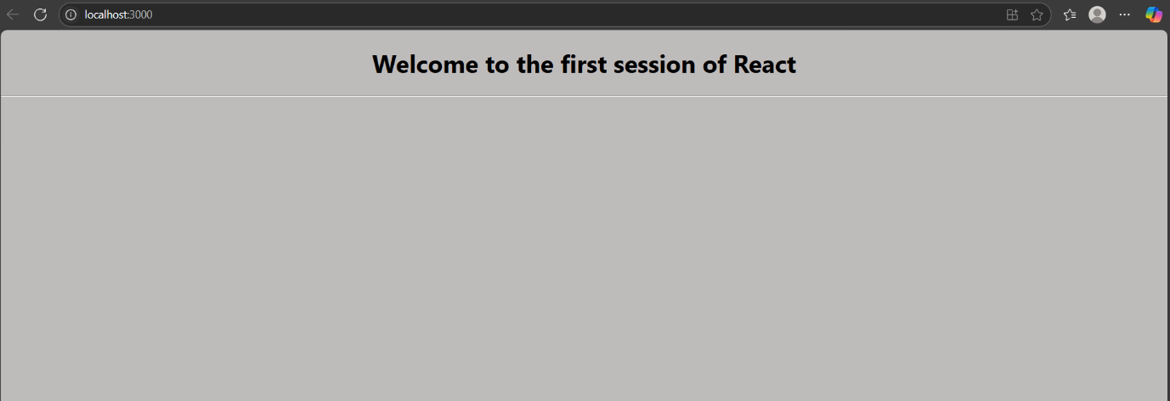

1. **Create a react app for Student Management Portal**

**Code:**

**App.js:**

import React from 'react';

import Home from './Components/Home';

import About from './Components/About';

import Contact from './Components/Contact';

function App() {

  return (

    <div>

      <Home />

      <About />

      <Contact />

    </div>

  );

}

export default App;

**Home.js**

import React from 'react';

function Home() {

  return (

    <div>

      <center><h2>1.Welcome to the Home page of Student Management Portal</h2></center>

    </div>

  );

}

export default Home;

**Home.js**

import React from 'react';

function About() {

  return (

    <div>

      <center><h2>2.Welcome to the About page of the Student Management Portal</h2></center>

    </div>

  );

}

export default About;

**Contact.js**

import React from 'react';

function Contact() {

  return (

    <div>

      <center><h2>3.Welcome to the Contact page of the Student Management Portal</h2></center>

    </div>

  );

}

export default Contact;

**Output**:

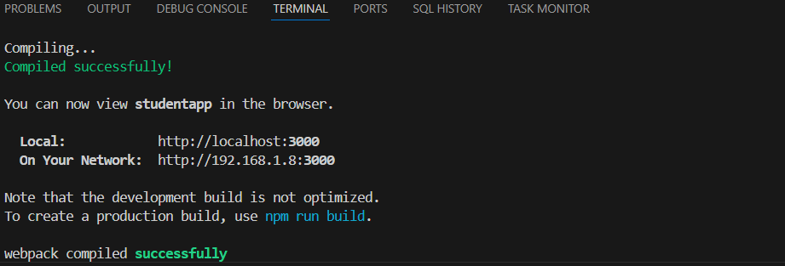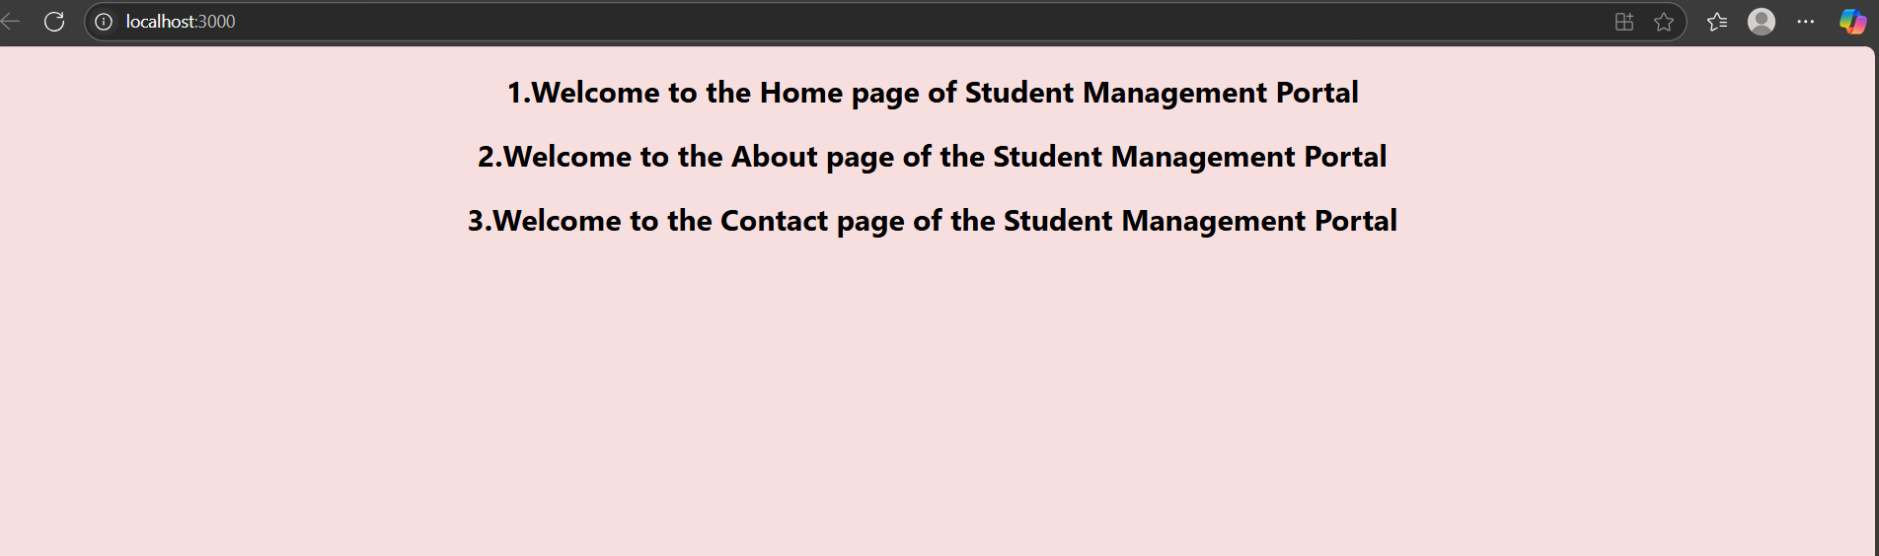

1. **Create a react app for Student Management Portal named scorecalculatorapp**

**Code**:

**App.js**

import React from 'react';

import CalculateScore from './Components/CalculateScore';

function App() {

  return (

    <div className="App">

      <CalculateScore />

    </div>

  );

}

export default App;

**CalculateScore.js**

import React from 'react';

import '../Stylesheets/mystyle.css';

function CalculateScore() {

  const name = "John Doe";

  const school = "Greenwood High";

  const total = 450;

  const goal = 500;

  const average = (total / goal) * 100;

  return (

    <div className="score-container">

      <h2>Student Score Calculator</h2>

      <p><strong>Name:</strong> {name}</p>

      <p><strong>School:</strong> {school}</p>

      <p><strong>Total Marks:</strong> {total}</p>

      <p><strong>Goal:</strong> {goal}</p>

      <p><strong>Average Score:</strong> {average.toFixed(2)}%</p>

    </div>

  );

}

export default CalculateScore;

**mystyle.css**

.score-container {

  background-color: #f0f8ff;

  padding: 20px;

  margin: 20px;

  border: 2px solid #4caf50;

  border-radius: 10px;

  font-family: Arial, sans-serif;

}

.score-container h2 {

  color: #4caf50;

  margin-bottom: 10px;

}

.score-container p {

  font-size: 16px;

  margin: 5px 0;

}

**Output**:

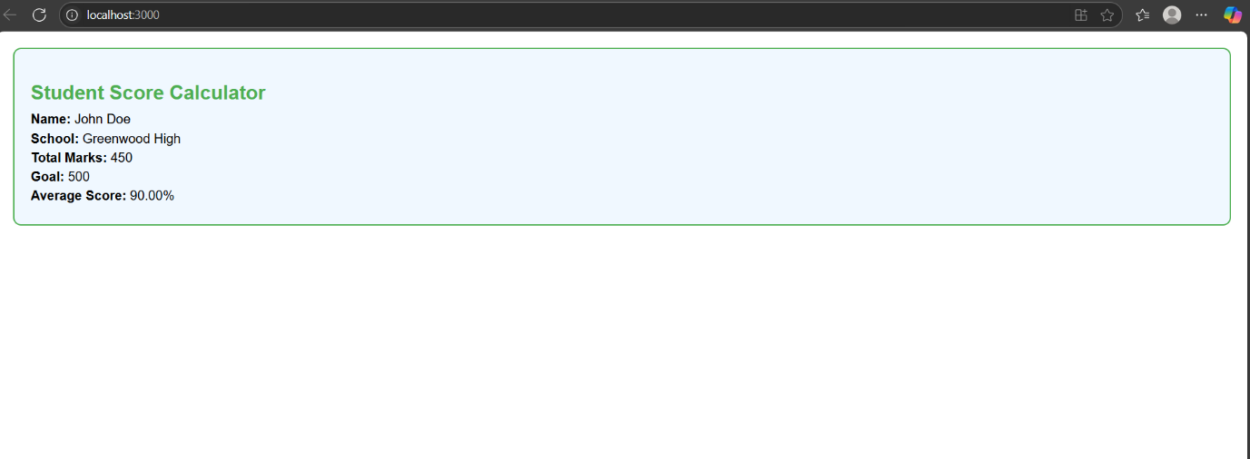

**4.Create a Blog App**

**Code:**

**App.js**

import React from 'react';

import Posts from './Posts';

function App() {

  return (

    <div className="App">

      <h1>Welcome to Blog App</h1>

      <Posts />

    </div>

  );

}

export default App;

**Post.js**

import React from 'react';

function Post({ title, body }) {

  return (

    <div style={{ border: '1px solid gray', padding: '10px', marginBottom: '10px' }}>

      <h3>{title}</h3>

      <p>{body}</p>

    </div>

  );

}

export default Post;

**Posts.js**

// src/Posts.js

import React, { Component } from 'react';

import Post from './Post';

class Posts extends Component {

  constructor(props) {

    super(props);

    this.state = {

      posts: [],

      error: null

    };

  }

  // Step 6: loadPosts() to fetch API data

  loadPosts = () => {

    fetch('https://jsonplaceholder.typicode.com/posts')

      .then((response) => response.json())

      .then((data) => this.setState({ posts: data }))

      .catch((err) => this.setState({ error: err.message }));

  };

  // Step 7: Call loadPosts inside componentDidMount

  componentDidMount() {

    this.loadPosts();

  }

  // Step 9: Catch and handle rendering errors

  componentDidCatch(error, info) {

    alert('Something went wrong while loading posts: ' + error);

  }

  // Step 8: Render posts

  render() {

    const { posts, error } = this.state;

    if (error) {

      return <p style={{ color: 'red' }}>Error: {error}</p>;

    }

    return (

      <div>

        <h2>Blog Posts</h2>

        {posts.map((post) => (

          <Post key={post.id} title={post.title} body={post.body} />

        ))}

      </div>

    );

  }

}

export default Posts;

**Output**:

